Kyle 您好

有一些問題, 想跟您請教一下

一、開發本機設定好.m2/settings.xml

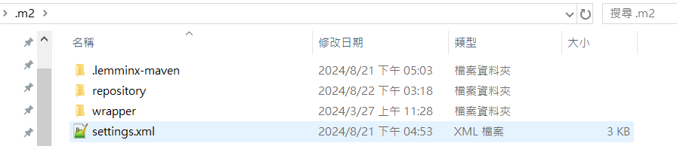

Settings.xml :

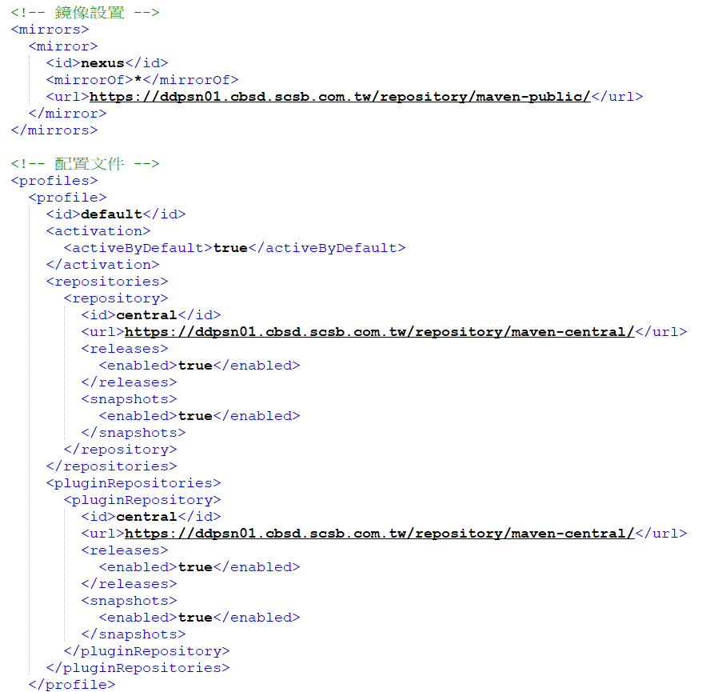

Eclipse 設定

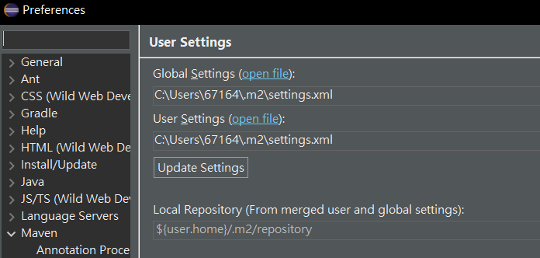

在eclipse 環境中, 會出現許多錯誤

Project build error: Non-resolvable import POM: The following artifacts could not be resolved: org.springframework.boot:spring-boot-dependencies:pom:3.2.0 (absent): Could not transfer artifact org.springframework.boot:spring-boot-dependencies:pom:3.2.0 from/to nexus (https://ddpsn01.cbsd.scsb.com.tw/repository/maven-public/): PKIX path building failed: sun.security.provider.certpath.SunCertPathBuilderException: unable to find valid certification path to requested target

看起來是憑證錯誤

將Nexus: <https://ddpsn01.cbsd.scsb.com.tw/> 的自簽憑證加入後

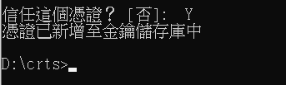

直接透過cmd 進行 build 是可以順利從 Nexus 抓取第三方套件

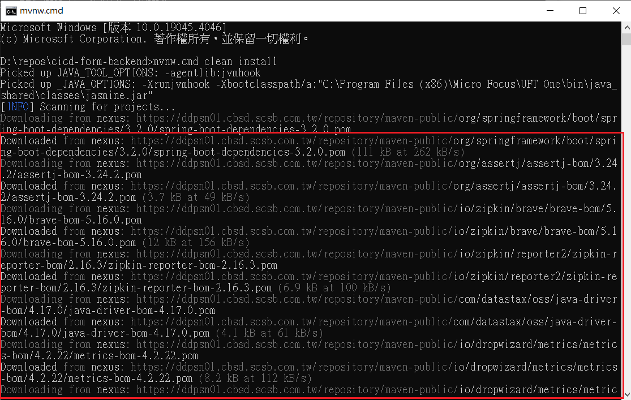

雖然透過cmd可以進行編譯, 但是eclipse的環境依然還是會報錯

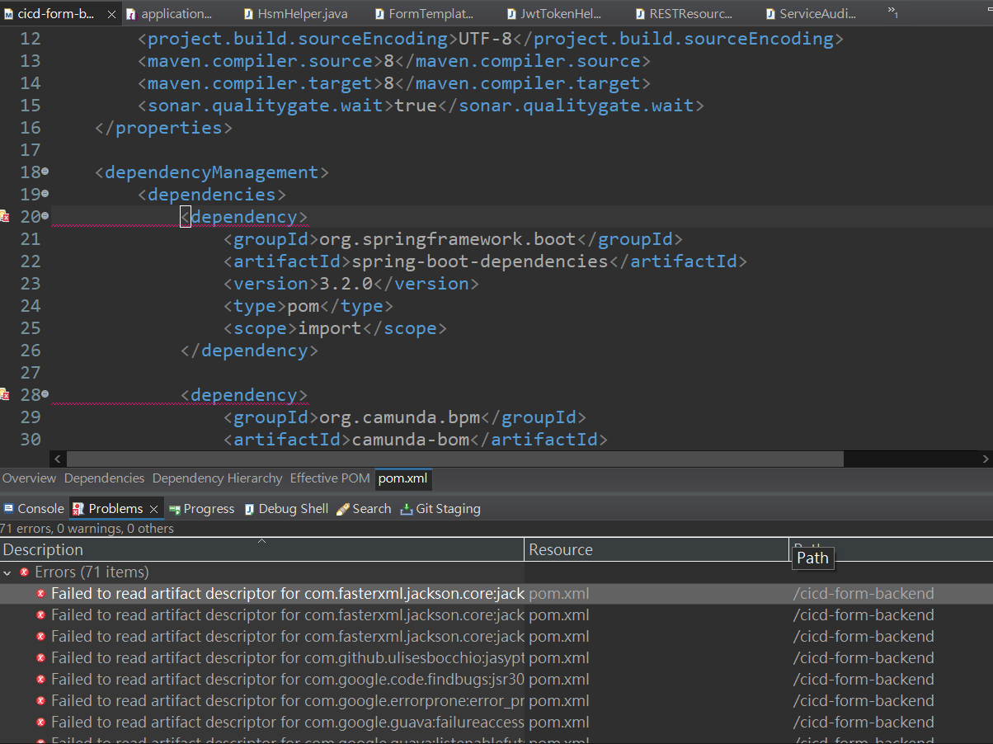

錯誤訊息是

Project build error: Non-resolvable import POM: The following artifacts could not be resolved: org.springframework.boot:spring-boot-dependencies:pom:3.2.0 (absent): Could not transfer artifact org.springframework.boot:spring-boot-dependencies:pom:3.2.0 from/to nexus (https://ddpsn01.cbsd.scsb.com.tw/repository/maven-public/): PKIX path building failed: sun.security.provider.certpath.SunCertPathBuilderException: unable to find valid certification path to requested target

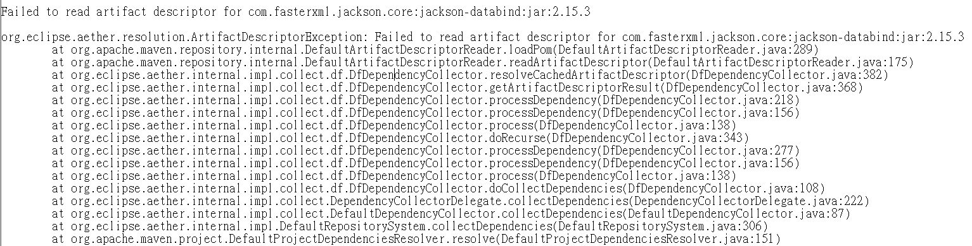

如果刪除掉憑證, 就會連 cmd也無法編譯

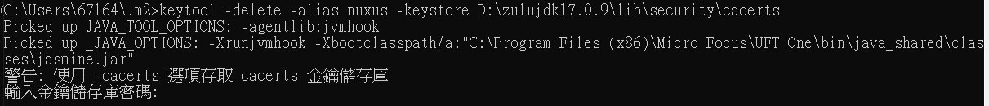

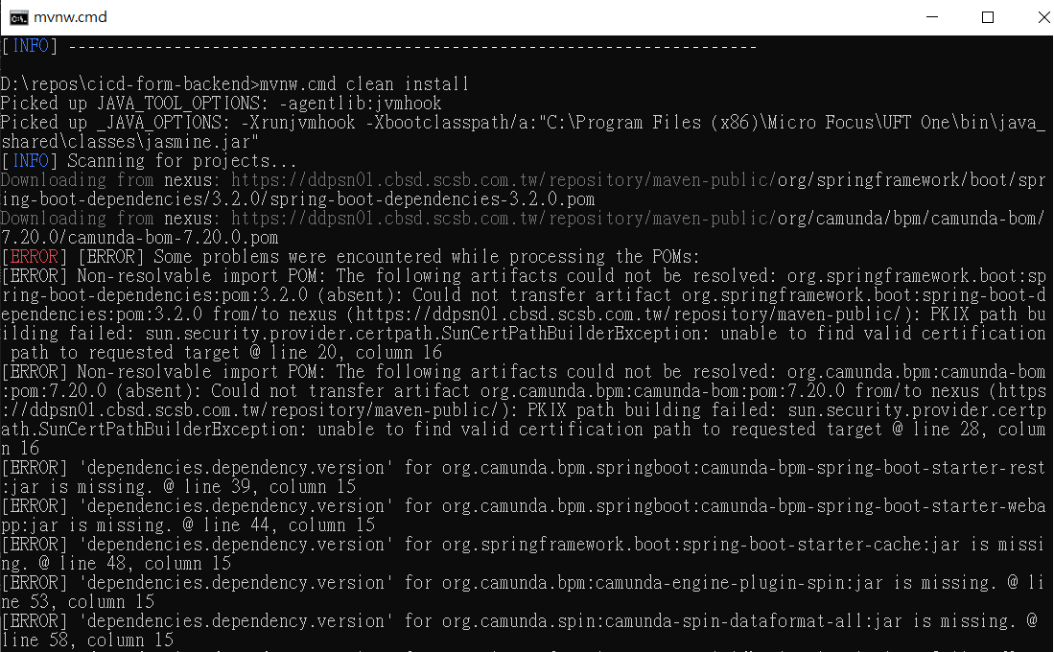

請問這個於開發本機的開發工具憑證問題, 有甚麼方法可以解決

二、Jenkins 版本適用於Java 11, 是否要升級至17

(1)之前有請您協助幫忙安裝 JDK 17 是否可以切換過去,

(2)是否可以記錄切換的步驟供行內參考, 以應對之後的升級

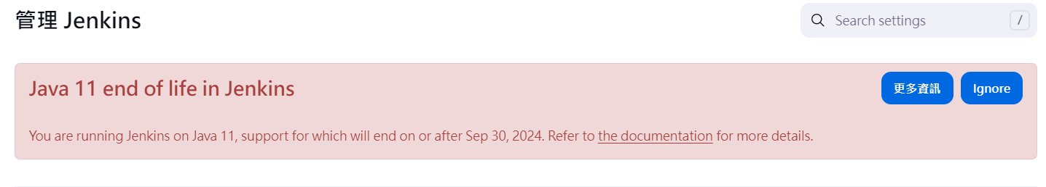

三、Nexus 網頁一直跳出錯誤, 以下是訊息, 請協助處理, 謝謝您

(1) Operation failed as server could not be contacted.

(2) Uncaught TypeError: Cannot read properties of null (reading 'success') (https://ddpsn01.cbsd.scsb.com.tw/static/rapture/nexus-coreui-plugin-prod.js?_v=3.42.0-01&_e=OSS:1)

